**Chapter 4**

**STUDY AREA**

For our project, we have considered 5 junctions: silkboard, hosur road, hosur road2, axatech, ring road.

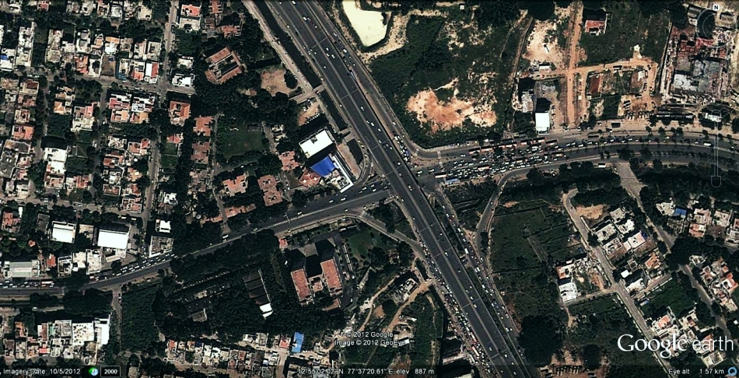

**Figure 4.1 silkboard junction**

**Areas considered:**

**Silkboard Axatech Hosur Road**

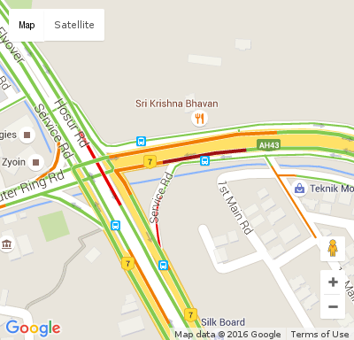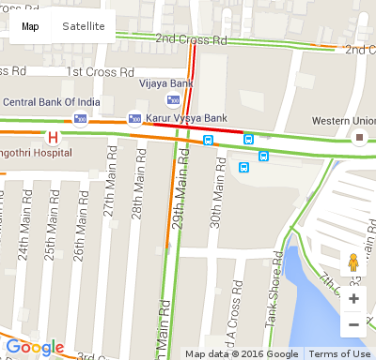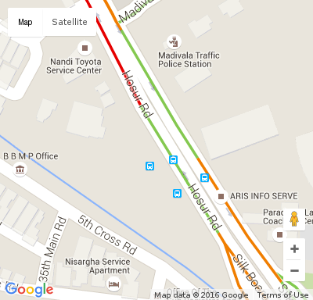

**Hosur Road 2 Ring Road**

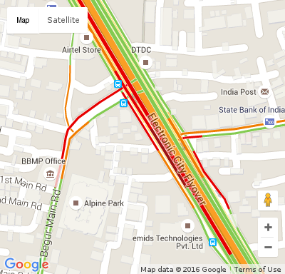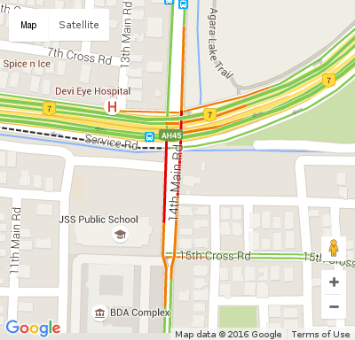

**Figure 4.2 Shows 5 junctions considered**

**4.1 Summary**

In this chapter we see the junctions under observation. The traffic layer of the junctions provided by google maps are shown in the Figure 4.2 .The colour in the image represents different traffic densities. Red line represents high density traffic, yellow line represents moderate and green line represents low density traffic. Images are taken for every one minute.